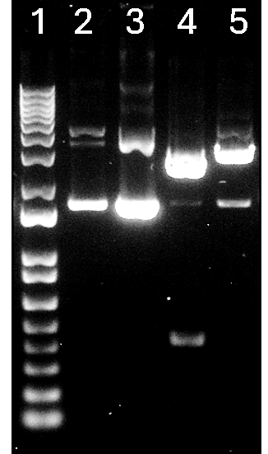

 | Distance Travelled - cm | Distance Travelled 2nd band - cm | DNA Band (kb) | 2nd DNA Band (kb)
Lane 2 | 5.30 |  | 5.8
Lane 3 | 3.70 | 5.40 | 7.9 | 5.6
Lane 4 | 4.28 |  | 7.1
Lane 5 | 3.98 | 5.40 | 7.5 | 5.6
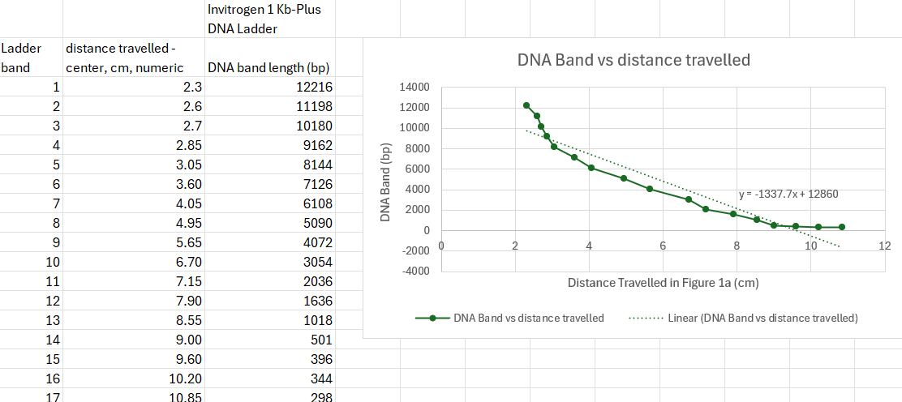
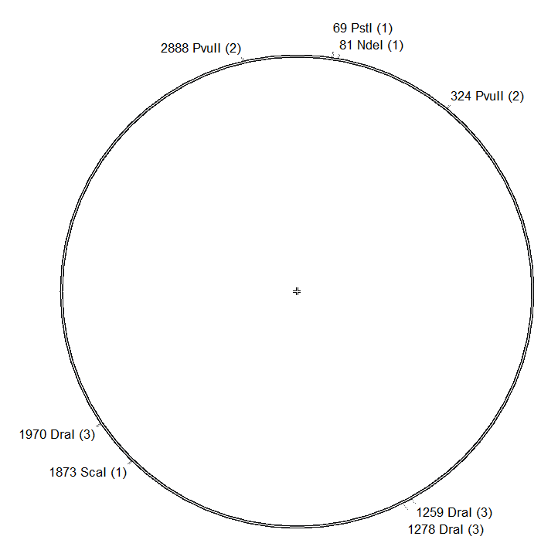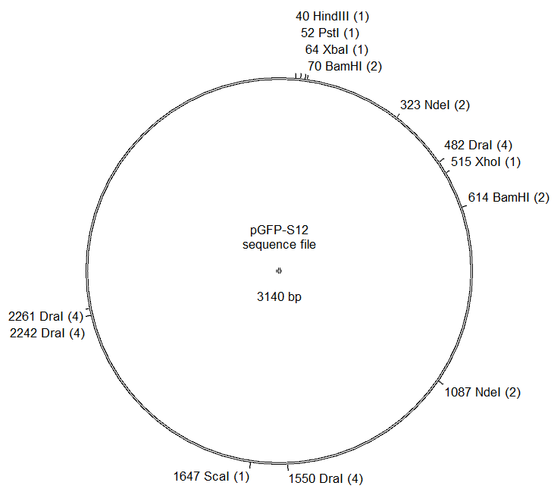

2. Plot the distance travelled against the log of the DNA size. You may do this manually or through a graphing program (e.g. Excel). Draw a line of best fit through your points.
3. Use the standard curve to estimate the sizes of the fragments in your digests. Report your fragment sizes in kb and round to one decimal place.
What can you conclude about the identity of this plasmid?
How confident are you about these findings?
4. Examine each lane of your gel and compare the fragment sizes generated by each digest with the predicted fragment sizes for pGEM-T and pGFP-S12. Pay attention to the relative intensities of the bands. Note that your observed fragment sizes are not going to be an exact match for your predicted sizes, but they should come close.
(a) Compare each restriction digest against your uncut plasmid control. Can you use your control sample to explain any bands that may be seen in your other samples? Outline your reasoning.
(b) If there are other bands on your gel that are not as predicted, can they be explained through a partial digest of your plasmid? i.e. could your enzyme have cut only some of the sites? Outline your reasoning.
5. When you look at your overall results, are they more consistent with the predicted results for pGEM-T or for pGFP-S12, or are they inconclusive? Explain your reasoning briefly.
6. Evaluate the quality of your data: How much do you trust your results and your conclusions about the identity of your plasmid, and why?
7. Troubleshooting: What could you do to improve the clarity of your results? In other words, what would you do next time to make your data more convincing?
8. Compare your results with peers—they may have chosen similar or different restriction endonucleases for their analyses. List their names, describe their results, and discuss whether their results strengthen or weaken your own findings. (The forums on the online course site are a good place to start this discussion.)
Evaluate the quality of your results, create a publication-quality figure of your analysis, and include a write-up that describes, explains, and interprets your results. This assignment is to be done individually, and is due in Lab 4.
Refer to Presenting your work as a journal article (Lab Protocols) for tips on how to format your table and figure, and how to write up your findings for a Results section vs. a Discussion section of a journal article. It may also be helpful to check the grading checklist (in Student Rubrics).
1. Create a formal table that lists your selected restriction digests and their predicted sites and fragment sizes for both pGEM-T and pGFP-S12. Number and title the table appropriately.
2. Create a digital plasmid map of both plasmids (use your favourite plasmid editor site; e.g. APE).
Label the maps and label the site and location of all restriction endonucleases available to the class.
- all restriction endonucleases available to the class.
  - BamHI DraI HindIII NdeI
  - PstI PvuII(HF) ScaI(HF) XbaI XhoI
Note: The map does not need to be drawn to scale, but it should show the relative positions of the restriction sites, and should be easily read (avoid fonts smaller then 10 pt)
Plasmid editors may be used if desired. For example, ApE—A Plasmid Editor—is a free program available online: http://jorgensen.biology.utah.edu/wayned/ape/
3. Take the image of your gel results (raw data) and process it appropriately into a labeled figure.
4. Add a figure caption to your plasmid map and gel results. Since the table, plasmid maps and gel image represent one single experiment, they should be combined into a single figure with parts A, B, etc. and a single caption. The figure caption should have a single number and overall title, with subtitles for each part. The caption should describe the data that is being shown in each part.
5. Write up to one double-spaced page on your figure—the page limit refers to the text only. Include the following information:
• Explain the question to be solved and the experimental technique being used to solve it.
• Describe the data being presented and explain what they mean.
• Refer to the relevant figure number so that the reader knows where to look for this data.
• Compare the observed fragment sizes with the predicted sizes, and establish which plasmid you have. Describe the actual numbers in your explanation—as if your reader cannot see your figure.
This assignment will eventually be in the Results section of your final Cloning report.
You may have more to say about the quality of your results, the errors that could explain unexpected results, and improvements to the experiment. Keep notes on these topics in your lab notebook—this further discussion of your findings belongs in the Discussion section of your final report.

Figure
FIGURE
• Show your own data.
• Single figure with parts (represents one experiment); parts are labeled A, B, C, etc.
• figure number, figure title, and a single caption. Each part should have its subtitle (so overall figure title plus titles for A, B, etc)
• descriptive titles and caption (caption describes what the data is; if lanes are numbered, they are defined here; if other symbols are used, they are explained here)
• computer-generated- even your plasmid map should be computer generated
• clear spelling/grammar/style

Table:
• predicted fragment sizes; units of measurement (bp or kb) and restriction digests indicated;
• Does not need a table title since this would be part A or B of the overall figure; if they do have a title it should go above the table.

Plasmid map: plasmid name, plasmid size, restriction sites, and nucleotide numbers all indicated (computer generated/Do not hand draw using a tablet)

Gel: ladder shown/ pertinent sizes labelled or tick marks at the side to show sizes; lanes are labelled; gel is cropped to show their own data (optional to crop wells out); no alteration of data. OK to draw attention to specific bands as long as there is reason to do this and it’s explained in the caption/text.

5 pts
This criterion is linked to a Learning Outcome Results
• The question is posed
• states what experiment is carried out to answer the question.
• text refers the reader to the figure number
• observed and predicted fragment sizes are compared; observed sizes are reasonable and predicted sizes are correct; actual numbers are described instead of expecting reader to work it out from the figure.
• plasmid is identified and reasoning is explained (where results are truly inconclusive: a clear line of reasoning about why they could not conclude what plasmid they had)
• well-organized ideas; writing flows smoothly; completeness (content and depth); within page limit (about 1 double-spaced page)

15 pts
Total Points: 2

